Azure Storage Account:

* 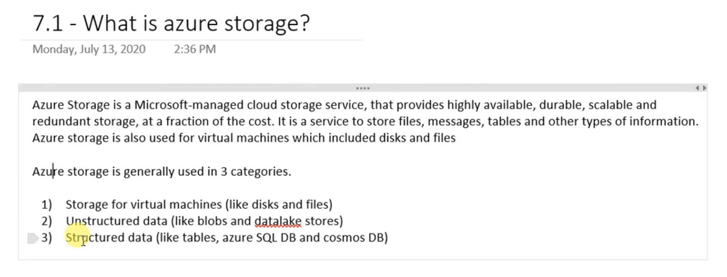

Azure Storage Types:

* 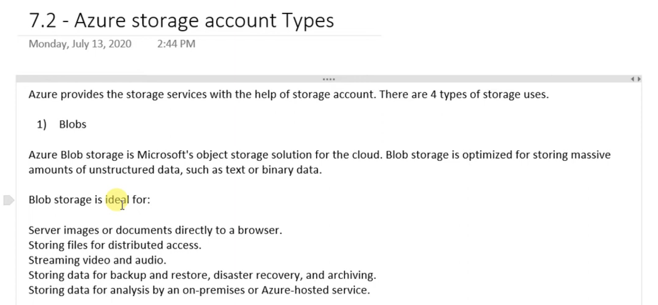
* 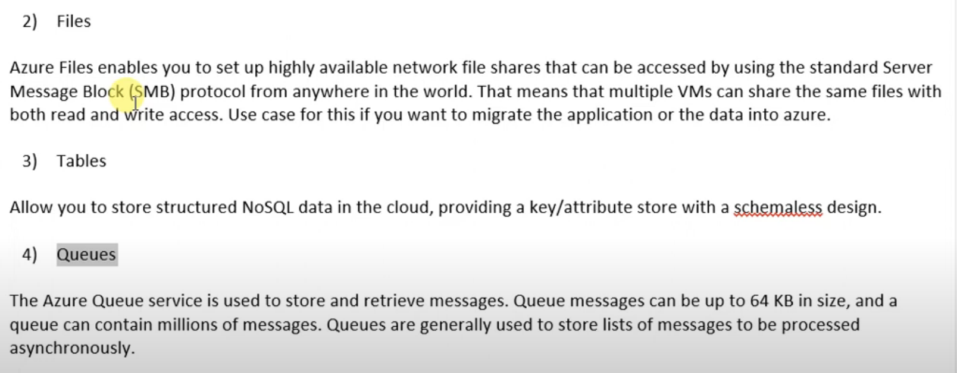

Storage Account Performance:

* 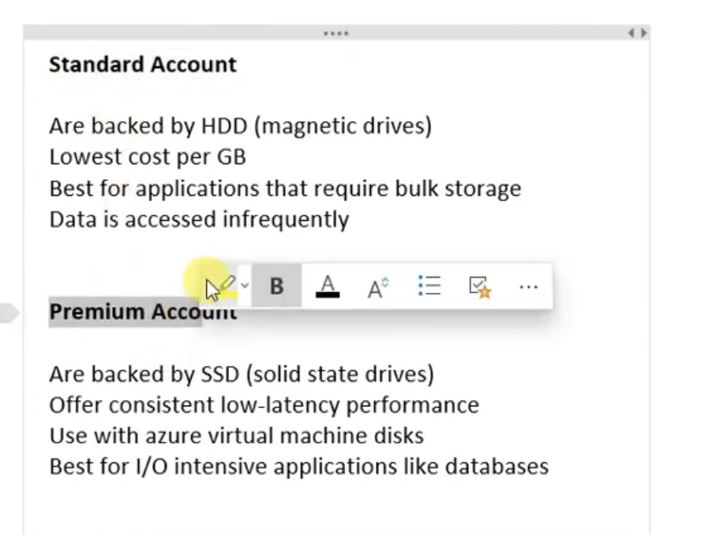

Storage Kinds:

* 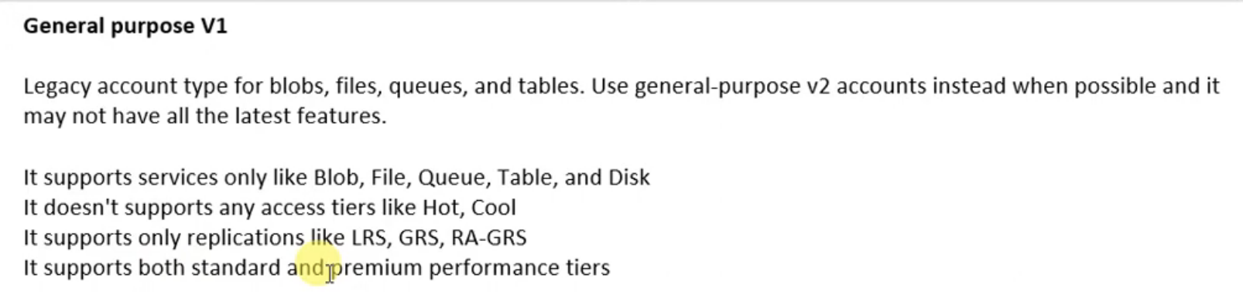
* 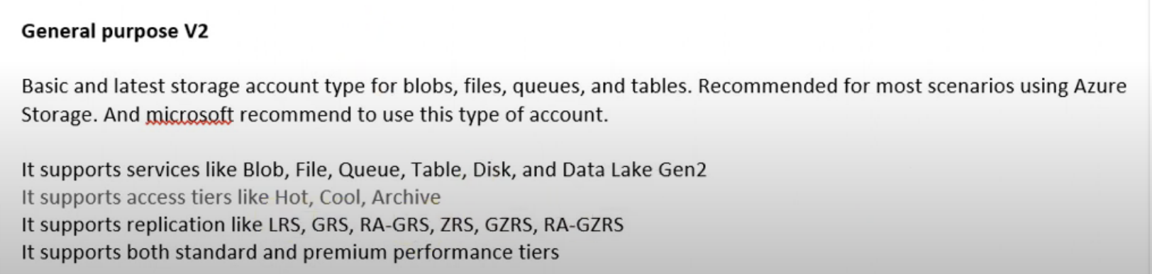
* 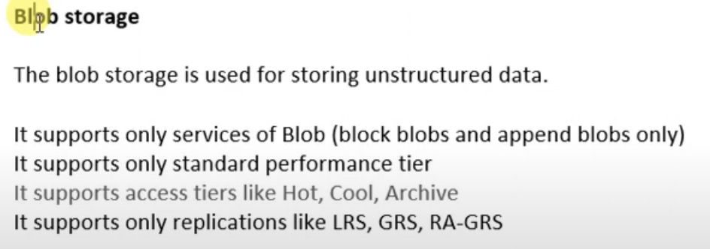

Azure Access Tiers:

* 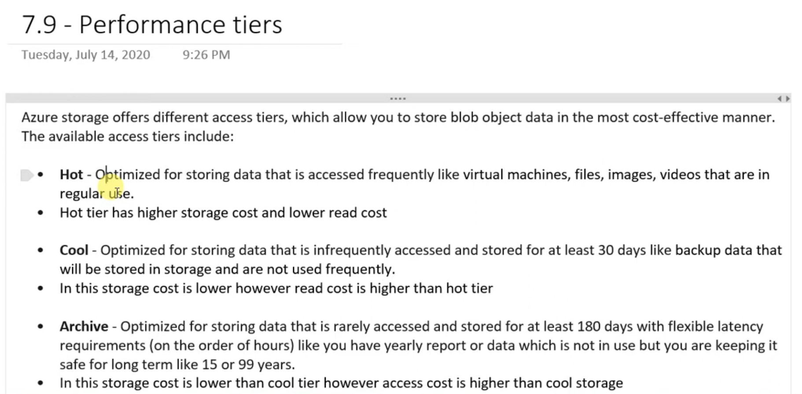

Blob Containers & Categories:

* 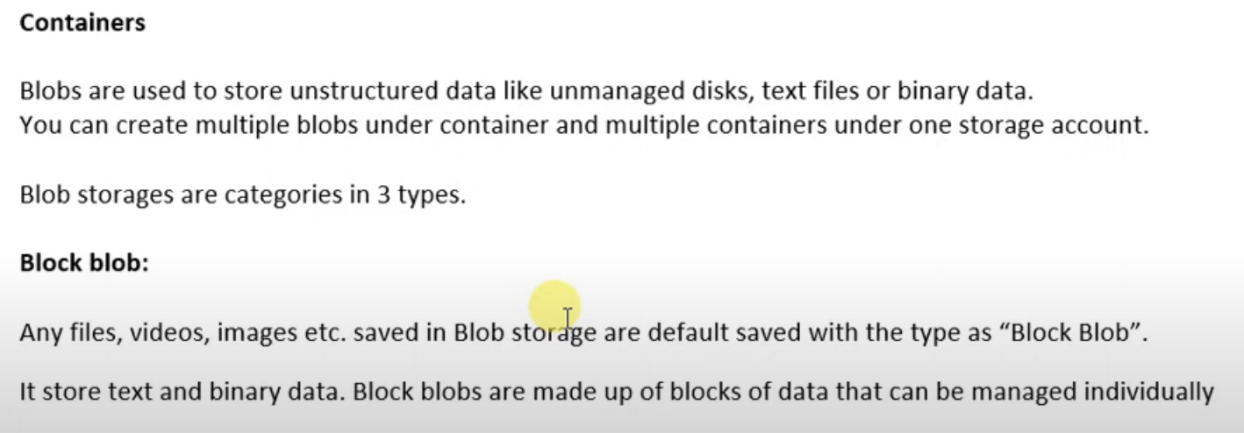
* 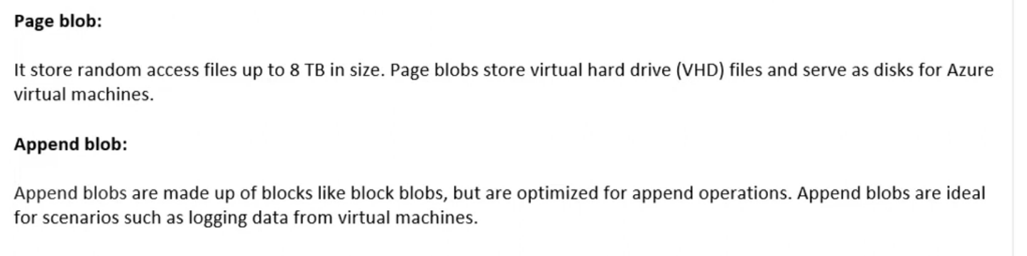

It is just a category defined for different file types

Storage Replication:

* 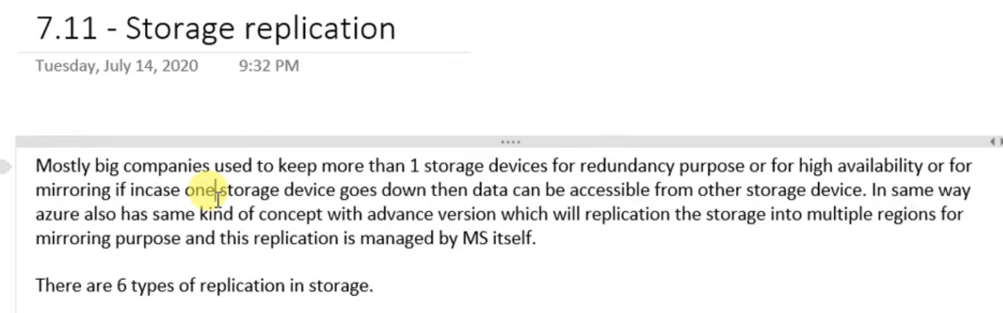
* 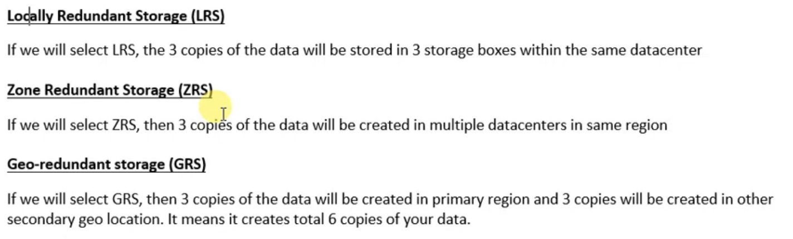
* 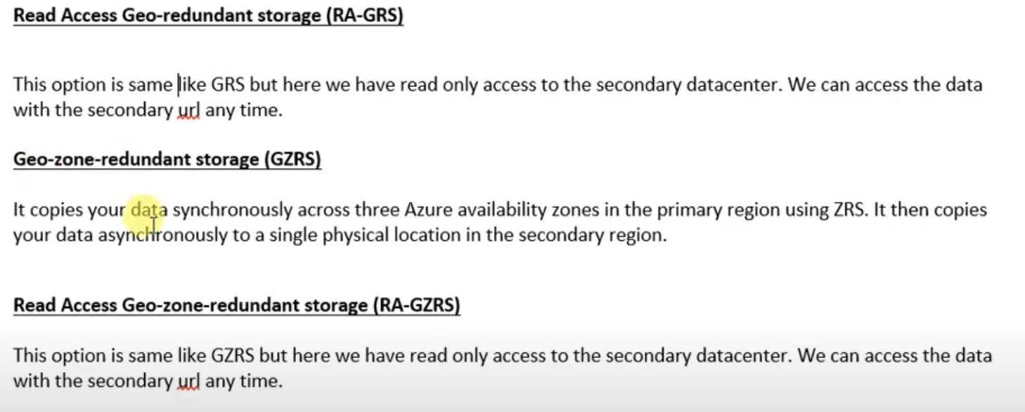
* Synchronously means data is getting written and replication is also done parallelly,
* ASynchronously means data which is already written is getting copied
* 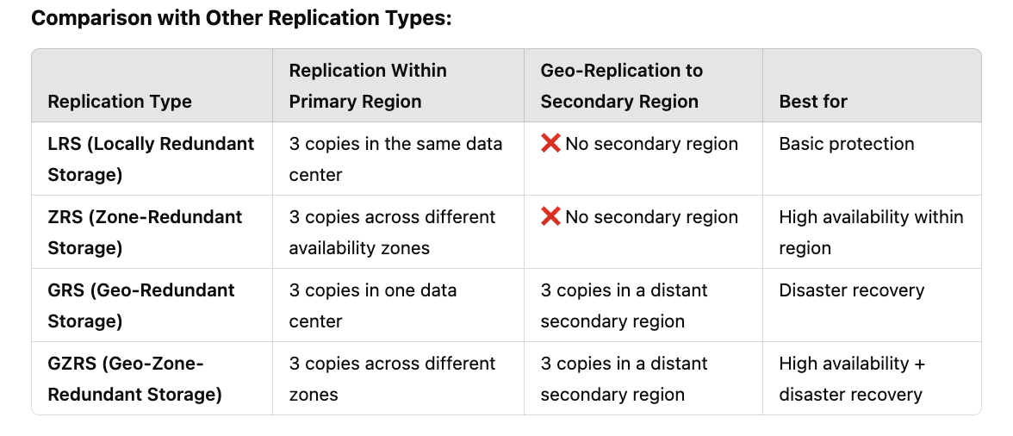

Network:

* 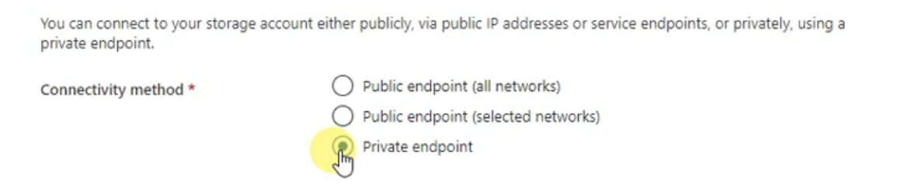

We can make blob publicy accessable or private or public with specific endpoint

* 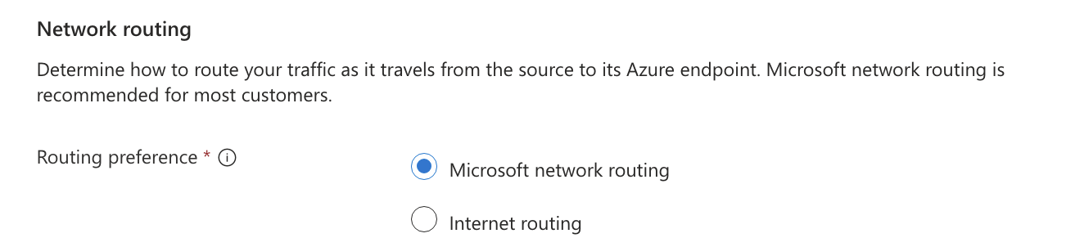
* With respect to routing if we choose Microsoft network routing it uses Microsoft n/w and latency will be less, if we use internet routing it used network routing of ISP and latency will be high

Data Protection:

* 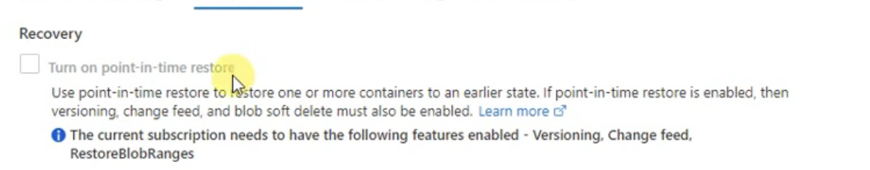

If blob is deleted or corrupted, it will be restored in latest previous state

* 
* If blob gets deleted u can recover in 7 days
* 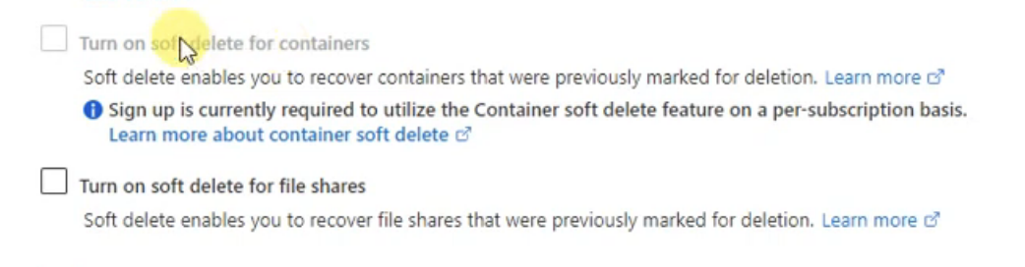

Versioning:

* 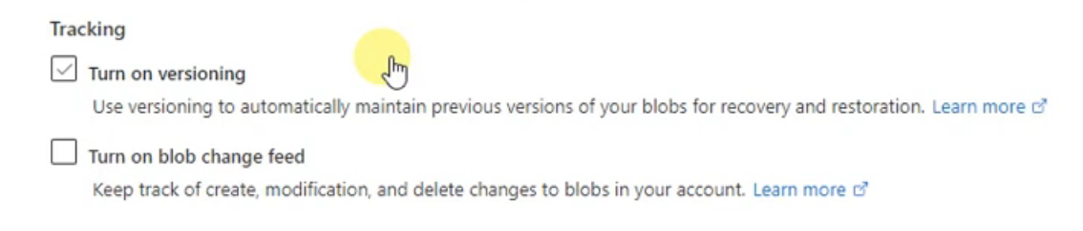
* 

Turn on Blob Change feed will keep logs of all changes done for a blob, helps in tracking

Advanced Section:

* 
* TLS: Transport Layer Security, communication between client and azure storage will be encrypted. It maintains data integrity and data security

Encryption:

* 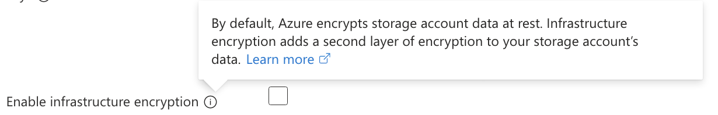
* 

We can amount storage as network drive

Azure Storage Explorer:

It’s a utility with which we can connect to azure storage

* 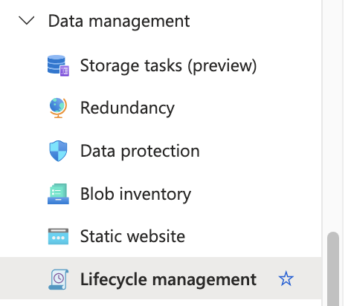
* 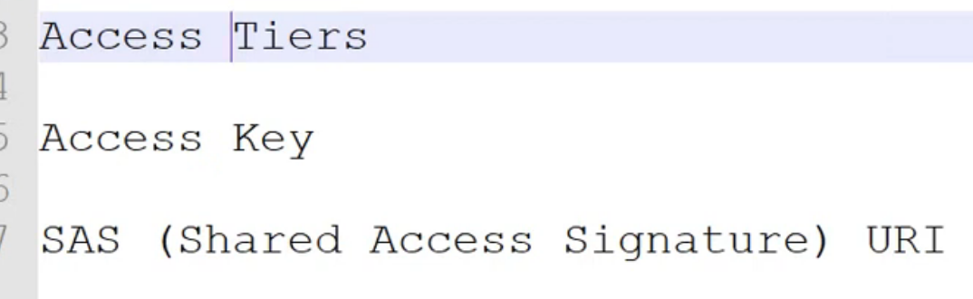

File Share:

It is used when you want to lift and shift the storage, like you can add this storage to any azure VM

Table Storage:

You can store structured data in tables

Queues:

We can store messages generated continuously, max size can be 64KB

Blob Service:

* 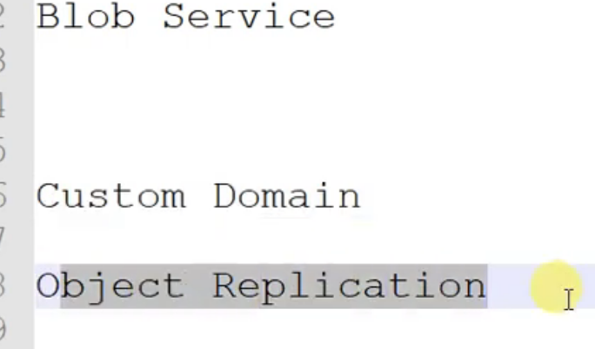
* 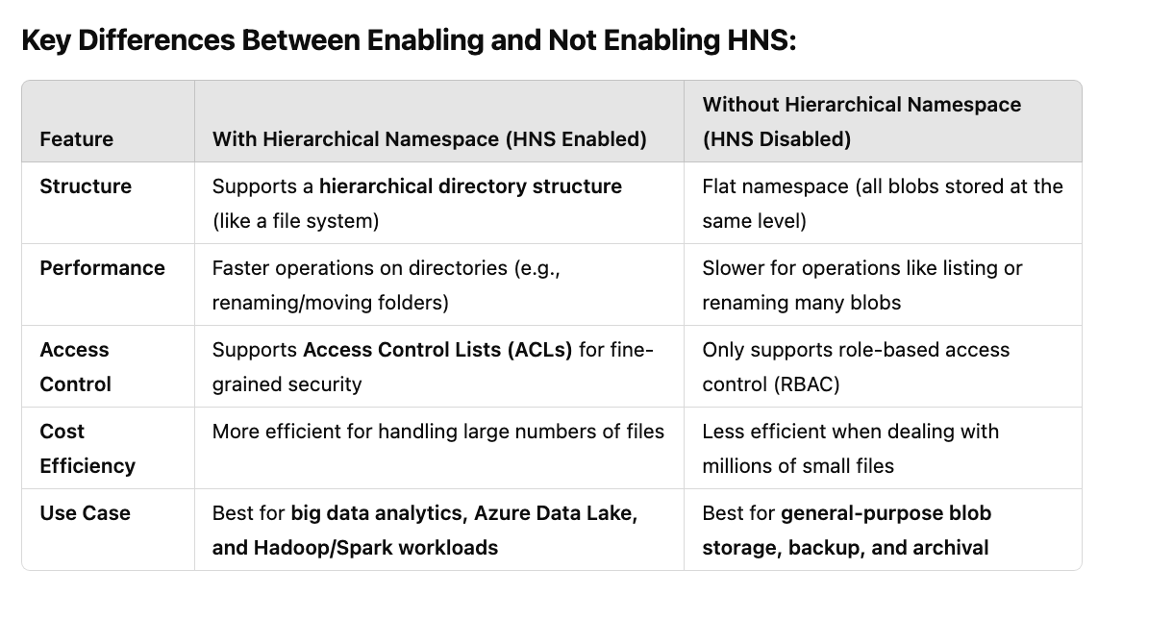

It will show only when ADLS GEN 2 is disabled

We can set a custom domain

* 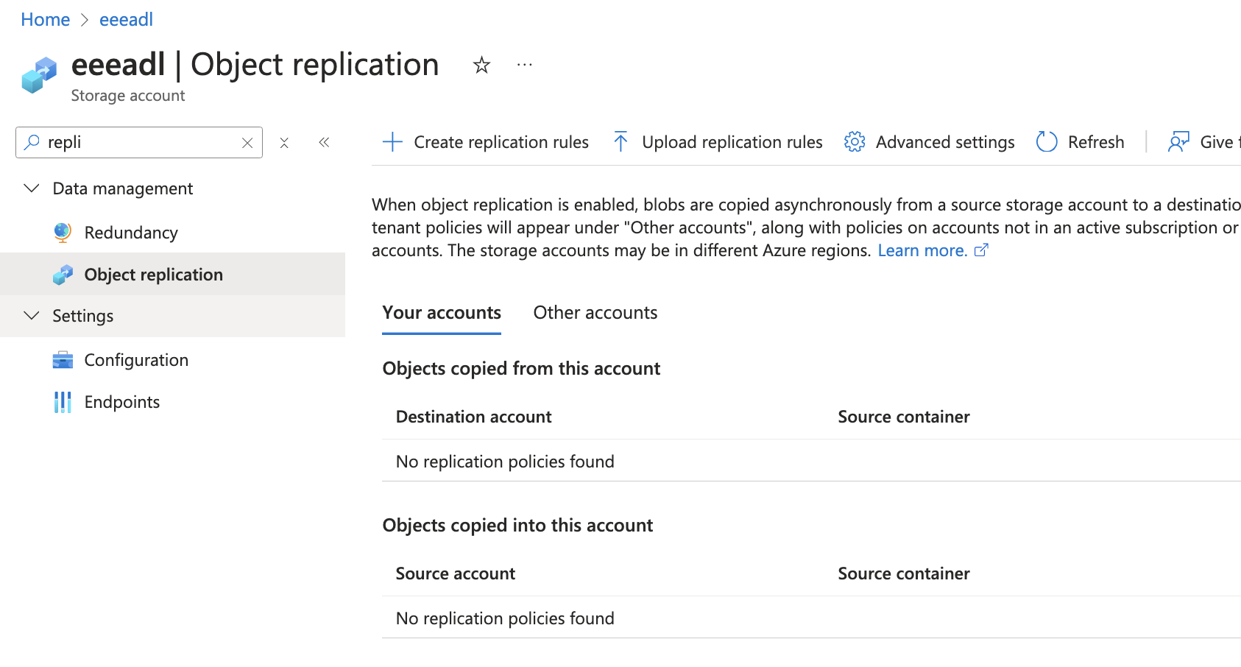

Azure Content Delivery Network:

* 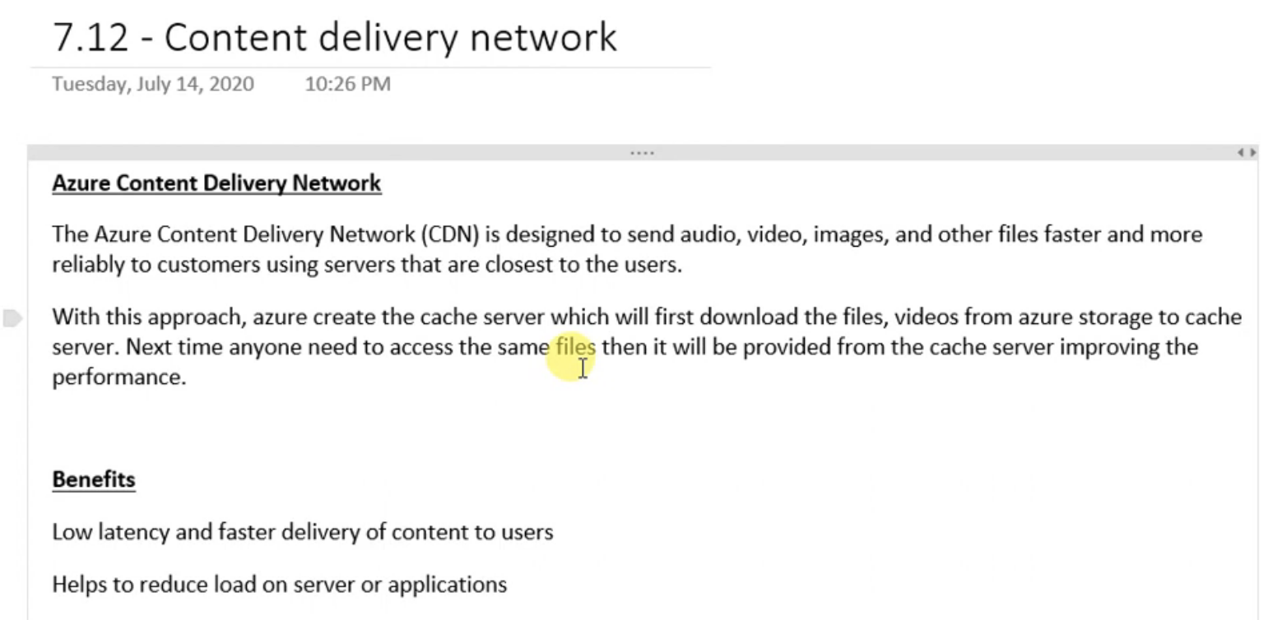
* 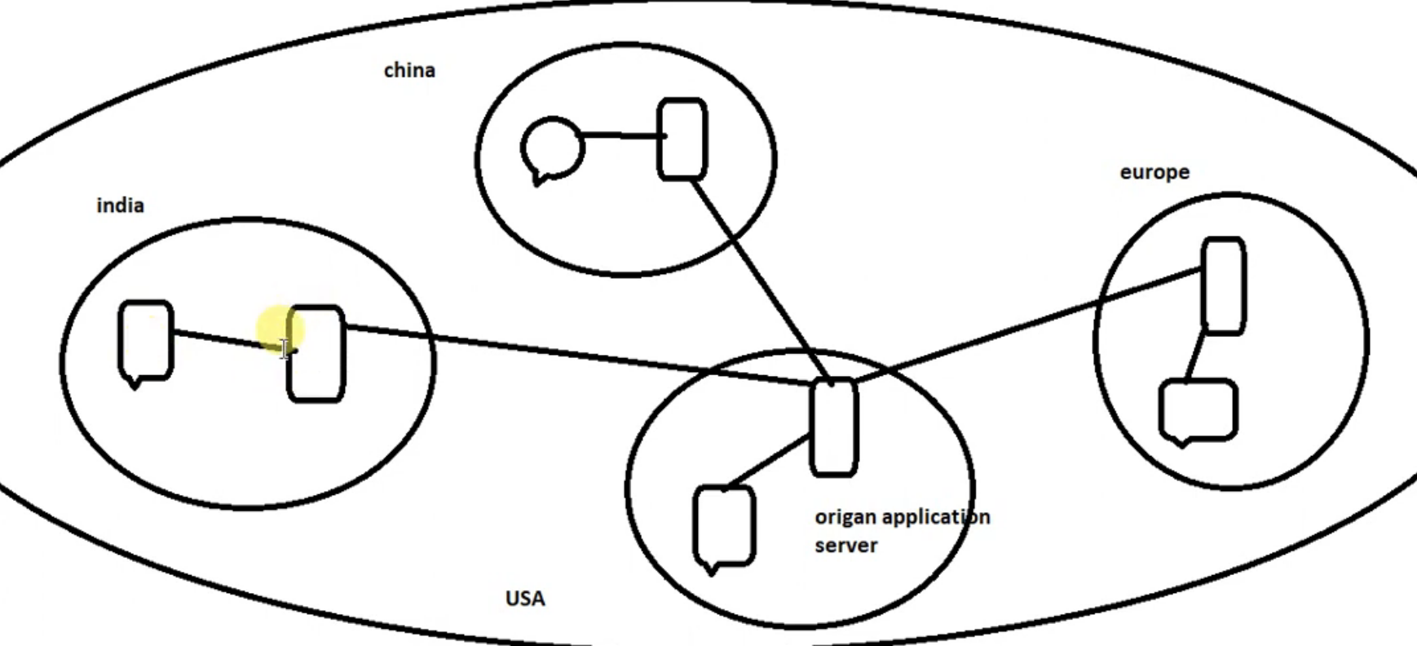
* 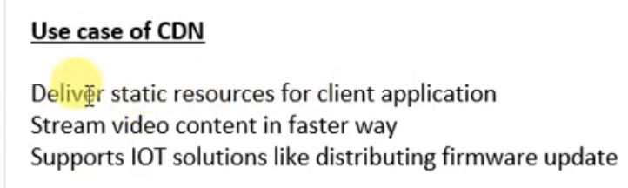
* 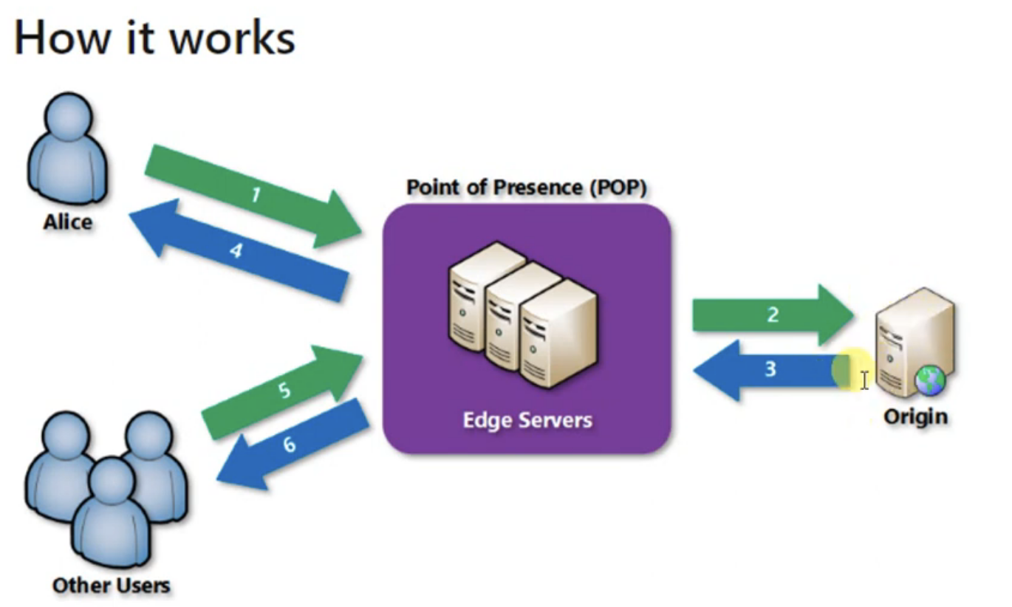
* 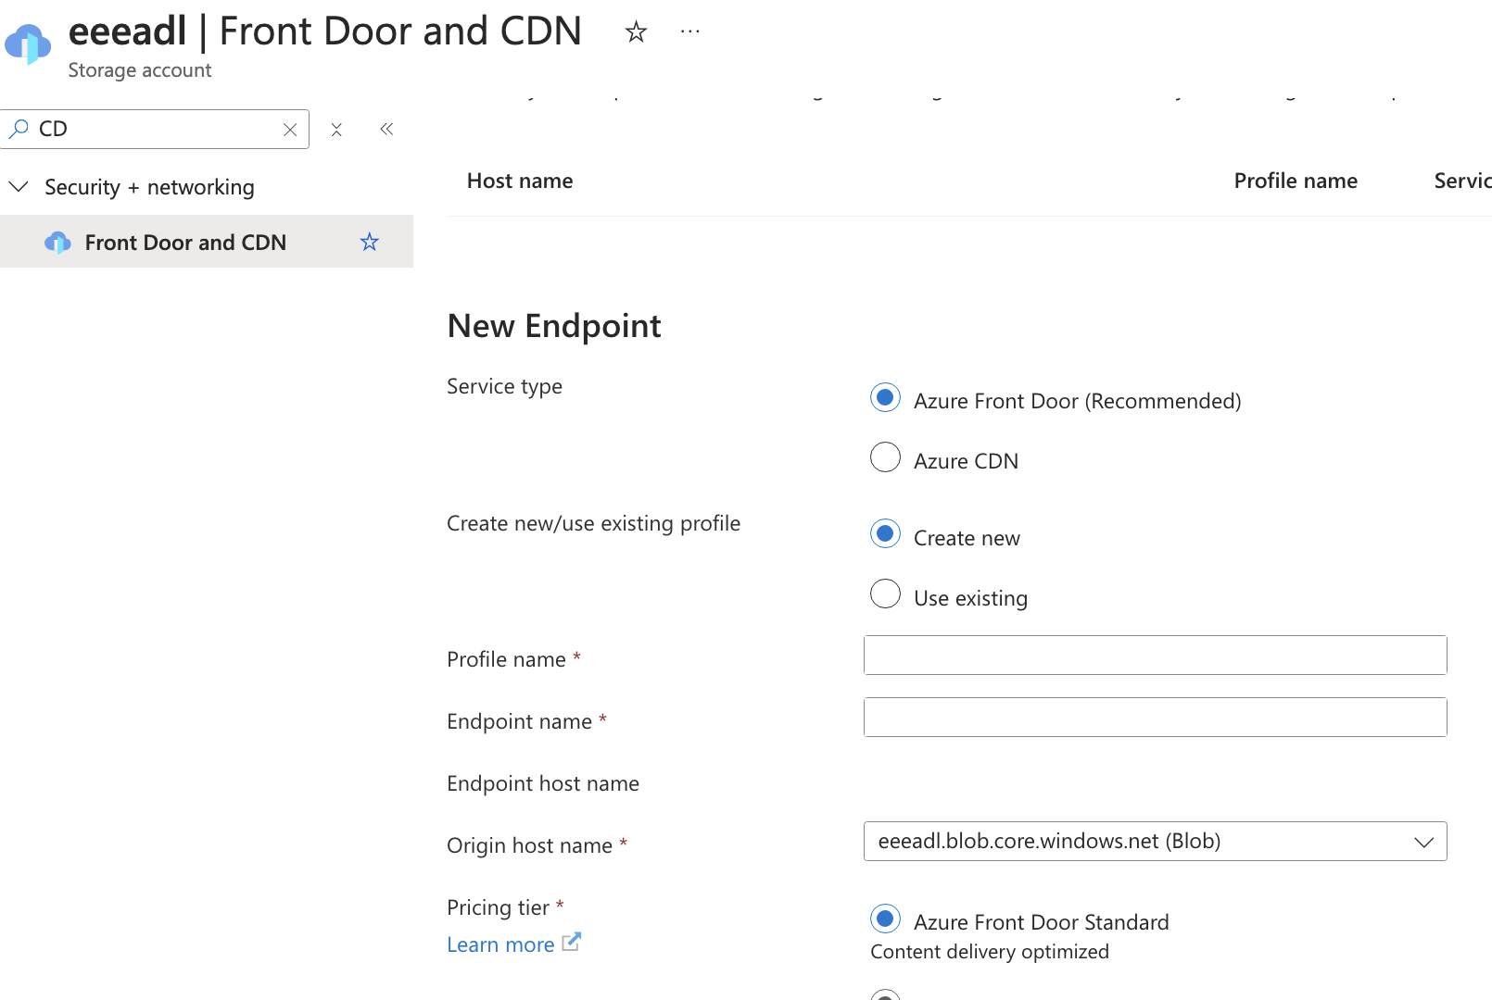

Azure File Sync:

* 